MIAE 221 • Midterms after 2020
Concordia University | Mamoun Medraj attribution check | 21 October 2026

Result: no confirmed matching paper yet
No post-2020 midterm could be verified as Mamoun Medraj’s from the sources checked. This is a screened screenshot-and-link catalogue, not a collection of complete exam papers and not proof that no matching paper exists.
Seven dated recent listings are documented below: one 2025 exam lead with an unverified instructor, five listings naming different instructors (including an apparent duplicate pair), and one generated practice listing excluded from authentic past exams.

Scope and limits
“After 2020” means exam dates 2021–2026, not upload dates or academic-year metadata. Older 2003, 2009, 2012 and 2017 papers were excluded, even when uploaded more recently. Reviews, equation sheets and undated samples are not counted as qualifying midterms.
Checked the signed-in MIAE 221 course catalogue with the search term midterm, recent individual listing previews, and targeted web searches for 2021–2026 Medraj papers. Some previews are scans with no readable text layer; visual headers were used where legible. This was not an exhaustive page-by-page audit of every alternative course catalogue.
Open the Studocu listing
Screenshots below show listing titles and metadata only; exam questions and complete solutions are not reproduced. Use the source links to inspect the originals through your Studocu account.

2025 • instructor unverified

MIAE 221–Midterm A–2025 Exam Solutions and Key Concepts
The visible paper header reads MIAE 221 – Materials Science – Midterm 2025, Version A. The preview does not establish Mamoun Medraj as instructor. Listing describes solutions. Retained as a recent exam lead, not a confirmed Medraj exam.
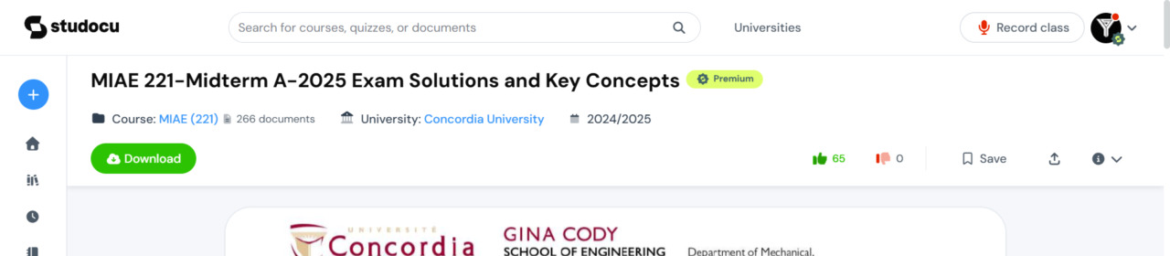
Listing preview captured 21 October 2026.
Open the Studocu listing
Studocu document ID: 124560047

Fall 2024 • different instructor

Midterm Solutions for MIAE 221 – Fall 2024 Exam Review
Visible scanned header names Dr. Martin Pugh, section X-A. Excluded from the confirmed Medraj set. Appears to reproduce the same Fall 2024 X-A paper as listing 110496507; not counted as a distinct exam.
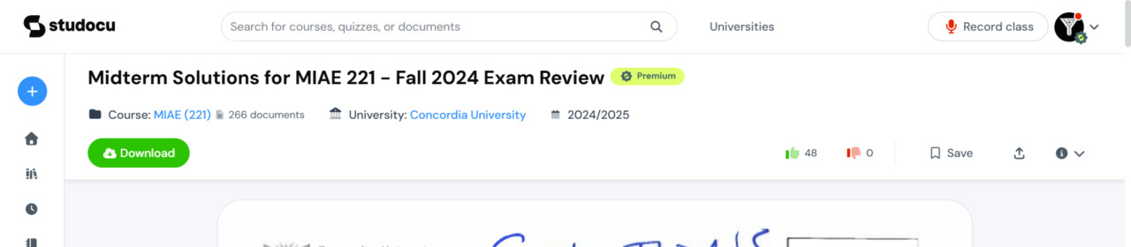
Listing preview captured 21 October 2026.
Open the Studocu listing
Studocu document ID: 112451179

Fall 2024 • different instructor

Midterm Solutions for MIAE 221 – Fall 2024 – Section X-A
Visible scanned header names Dr. Martin Pugh, section X-A. Excluded from the confirmed Medraj set. Solutions listing; overlaps listing 112451179.
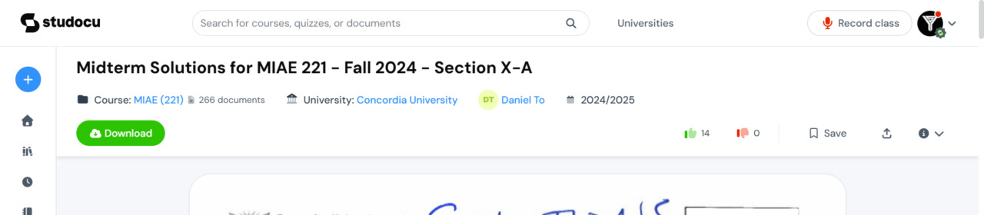
Listing preview captured 21 October 2026.
Open the Studocu listing
Studocu document ID: 110496507

2025 title • generated practice, not verified past exam

MIAE 221 Materials Science Midterm Exam 2025
The preview says generated on 06.10.2026 and supplies practice instructions and QR-code feedback. A 2025 title does not prove this is an actual 2025 university midterm. Excluded from authentic professor-attributed past exams.
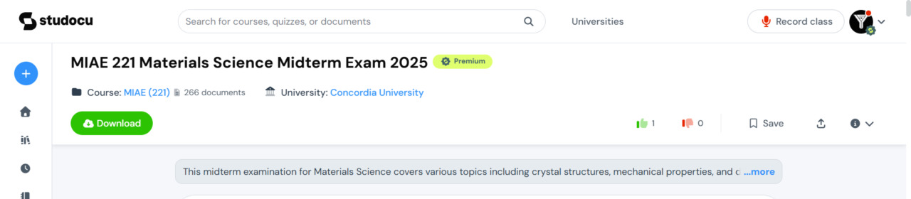
Listing preview captured 21 October 2026.
Open the Studocu listing
Studocu document ID: 174494848

Fall 2024 • different instructors

MIAE 221–T and Y – Midterm Solutions Fall 2024
Visible scanned header identifies sections T and Y and instructors Drs. Martin Pugh and Navid Sharifi. Excluded from the confirmed Medraj set.
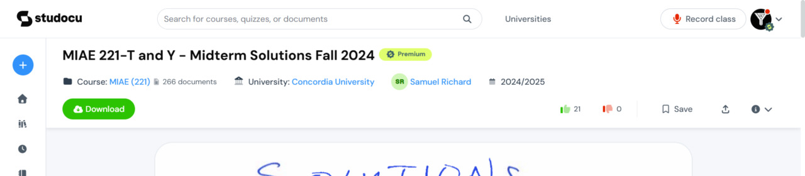
Listing preview captured 21 October 2026.
Open the Studocu listing
Studocu document ID: 108649883

Winter 2026 • different instructors

MIAE 221 Midterm Exam Solutions, Winter 2026
Visible scanned header reads MIAE 221 – Midterm, Winter 2026; instructors Drs. Mamadou Sy and Navid Sharifi. Excluded from the confirmed Medraj set.
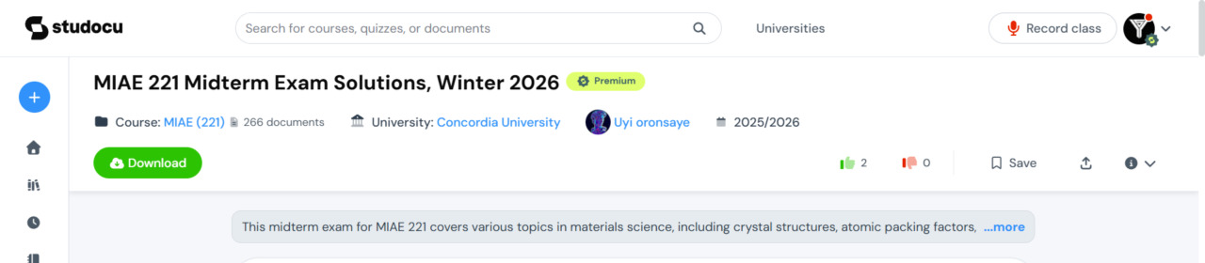
Listing preview captured 21 October 2026.
Open the Studocu listing
Studocu document ID: 159540505

Fall 2025 • different instructor

MIAE 221 Midterm Exam Solutions, Fall 2025 – Version A
Visible exam header reads MIAE 221/X – Midterm, Fall 2025; instructor Dr. Sam Eskandarian. Excluded from the confirmed Medraj set.
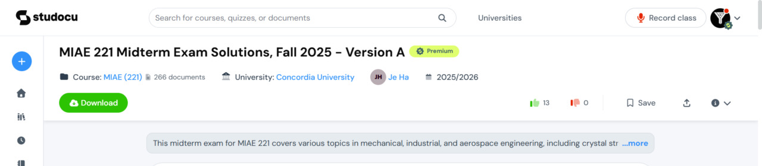
Listing preview captured 21 October 2026.
Open the Studocu listing
Studocu document ID: 144474318

